**1. INTRODUCTION**

Internal combustion engines are those engines which gives heat during the combustion of fuels in the presence of oxygen in the combustion chamber. After the combustion, the engine undergoes high pressure and high temperature. The conversion of the chemical energy to mechanical energy is done in the internal combustion engine. The transfer of the energy in the combustion chamber takes place with the help of action of piston and valves.

The internal combustion engines are widely used as the high temperature and high pressure can be reduced by the heat sink to the consistent temperature keep the system in running and these engines are used in motorcycle. The mechanism used in the engine is simple reciprocating piston and cylinder system, the movement of the piston in the cylinder makes the area a tight seal, the reciprocating motion of the piston connected to the connecting rod and the crankshaft arrangement, making the reciprocating motion to the rotary motion of the shaft.

The advantages of the internal combustion engines are lower cost, greater mechanical and thermal efficiency, easy to carry or portable.

**HISTORY OF ENGINES**

The first commercial successful internal combustion engine was created by Etlenne Lenoir in 1859 and next modern engine was created in 1876 by Nikolaus Otto.

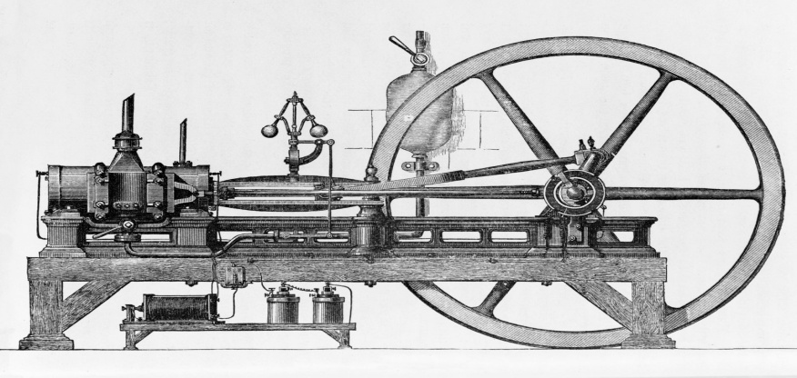

There by the history of internal combustion engines started to change to new models by many scientists and engineers as in 1872 an American George Brayton invented the first liquid fuel internal combustion engine , in 1886 Karl Benz invented the motor vehicle used internal combustion engine, in 1892 Rudolf Diesel developed the first compressed ignition engine[1].

**1.2 CLASSIFICATION OF INTERNAL COMBUSTION ENGINES**

1. Based on application

* Automobile Engine
* Aircraft Engine
* Locomotive Engine
* Marine Engine
* Stationary Engine

2. Based on basic engine design

* Reciprocating: Single cylinder, Multi-cylinder In-line, V, radial, opposed cylinder, Opposed Piston.
* Rotatory: Single motor, Multi motor

3. Based on operating cycle

* [Atkinson](https://me-mechanicalengineering.com/atkinson-cycle/) (For complete expansion SI Engine)
* [Diesel](https://me-mechanicalengineering.com/diesel-cycle/) (For the Ideal Diesel Engine)
* Dual (For the Actual Diesel Engine)
* Miller (For Early/Late Inlet valve closing type SI Engine)
* [Otto](https://me-mechanicalengineering.com/otto-cycle/) (For the Convectional SI Engine)

4. Based on working cycle

* Four stroke cycle
* Two stroke cycle
  + Scavenging ; direct/crankcase/cross flow; back flow/loop; Uni flow
  + Naturally aspirated or turbocharged

5. Based on Valve/port design and location

* Design of valve/port
  + Poppet valve
  + Rotatory valve
* Location of valve/port
  + T-head
  + L-head
  + F-head

6.Based on Fuel

* Convectional
  + Crude oil derivatives; Petrol, diesel
  + Other sources; coal, bio-mass, tar stands, shale
* Alternative
  + Petroleum derived: CNG, LPG
  + Bio-mass derived: alcohols, vegetable oils, producer gas, biogas and hydrogen
  + Blending
  + Bi-fuel and dual fuel

7. Based on mixture preparation

* + Carburetion
  + Fuel injection

8. Based on ignition

* + Spark ignition
  + Compression Ignition

9. Based on stratification of charge

* Homogeneous Charge
* Stratified charge
  + With carburetion
  + With fuel injection

10. Based on combustion chamber design

* Open chamber: Disc, wedge, hemispherical, bowl-in-piston, bath tub.
* Divided chamber:
  + (For CI) 1. Swirl chamber, 2. Pre-chamber
  + (for SI) 1. CVCC, 2. Other designs

11. Based on cooling system

* [Air-cooling system](https://me-mechanicalengineering.com/air-cooling-system-reciprocating-engine/)
* [Water-cooling system](https://me-mechanicalengineering.com/liquid-cooling-system-in-reciprocating-engine/)

**RECENT ADVANCES IN THE INTERNAL COMBUSTION ENGINES**

With continuous refinement of design and implementation of technologies has led internal combustion engines more efficient in recent years. According to Corporate Average Fuel Economy norms and pollution control guidelines, new innovation is necessary to increase mileage and emission of pollution needs to be controlled/reduce by the cars.

We see a new advancement changes in technologies in the future by the automotive industry.

The few technologies which could be conventional in the cars as follows

**1. Camless engines:** In this, infinite variable valve timing is being offered. With remapping of architecture of engine, we can change valve lift which helps in better performance of engine.

**2. DI Turbo Ethanol engine:** To increase efficiency of petrol engine as diesel engine, engines will have fuel injection system with direct injection turbo port which helps in higher compression ratios. To have more power E85 Ethanol would be injected to the direct injection system[2].

**1.3 Fuel injection system**

Fuel injection [3] is the advent of gas in an inner combustion engine, most typically automotive engines, through the manner of an injector.

All diesel engines use gasoline injection by using design. Petrol engines can use fuel direct injection, wherein the gasoline is directly brought into the combustion chamber, or oblique injection where the gas is mixed with air earlier than the consumption stroke.

On petrol engines, gas injection changed carburetors from the Eighties onward. The number one difference among carburetion and gas injection is that fuel injection atomizes the fuel thru a small nozzle underneath excessive pressure, even as a carburetor is based on suction created via consumption air multiplied thru a Venturi tube to attract the gas into the airstream.

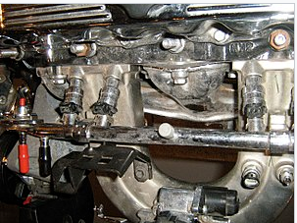

Fig 1.1

**Main Objectives**

The functional targets for gasoline injection structures can vary. All proportion the important assignment of providing fuel to the combustion manner, however it's miles a layout choice how a selected system is optimized. There are numerous competing goals along with:

• Power output

• Fuel efficiency

• Emissions performance

• Running on opportunity fuels

• Reliability

**Benefits**

Benefits of fuel injection include smoother and more constant brief throttle reaction, together with at some point of quick throttle transitions, easier cold beginning, greater correct adjustment to account for extremes of ambient temperatures and modifications in air stress, extra strong idling, decreased upkeep needs, and better fuel performance.

It also dispenses for a separate mechanical choke, which on carburetor-ready automobiles have to be adjusted as the engine warms up to regular temperature. Furthermore, on spark ignition engines, (direct) fuel injection has the advantage of being able to facilitate stratified combustion which has not been viable with carburetors.

It is best with the appearance of multi-point fuel injection positive engine configurations which includes inline five-cylinder fuel engines have end up more viable for mass production, as traditional carburetor arrangements with single or twin carburetors cannot offer even gas distribution between cylinders, unless a extra complicated individual carburetor in step with cylinder is used.

**1.4 Direct Fuel Injection System**

Common rail direct gasoline injection[4] is an immediate fuel injection gadget for diesel engines. It capabilities a excessive-strain (over 100 bar or 10 MPa or 1,500 psi) gas rail feeding solenoid valves, as opposed to a low-stress gasoline pump feeding unit injectors (or pump nozzles). Third-technology not unusual rail diesels now function piezoelectric injectors for expanded precision, with gasoline pressures up to two, 500 bar (250 MPa; 36,000 psi).

High pressure injection gives you power and gasoline consumption blessings over earlier decrease pressure fuel injection, by means of injecting gas as a bigger quantity of smaller droplets, giving a far better ratio of floor region to extent. This offers progressed vaporization from the floor of the fuel droplets and so extra efficient combining of atmospheric oxygen with vaporized fuel delivering more entire combustion.

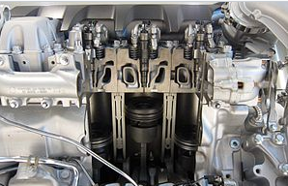

Fig 1.2

**Applications**

The commonplace rail device is suitable for all types of street motors with diesel engines, starting from metropolis vehicles (which include the Fiat Panda) to executive vehicles (inclusive of the Audi A8). The foremost suppliers of present day common rail structures are Robert Bosch GmbH, Delphi, Denso, and Siemens VDO (now owned through Continental AG)[13].

**1.5 Working Principle of CRDI**

Solenoid or piezoelectric valves make viable quality electronic manage over the gas-injection time and quantity, and the higher stress that the commonplace rail technology makes available offers higher fuel atomisation. To lower engine noise, the engine's electronic manage unit can inject a small amount of diesel just earlier than the primary injection occasion ("pilot" injection), therefore reducing its explosiveness and vibration, as well as optimising injection timing and quantity for versions in gas pleasant, bloodless starting, and so forth[14]. Some superior commonplace rail gas structures carry out as many as 5 injections in step with stroke.Common rail engines require a very quick to no heating-up time, relying on the ambient temperature, and convey lower engine noise and emissions than older systems[15].

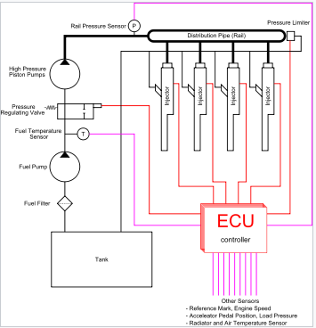

Fig 1.3

Diesel engines have historically used various forms of gasoline injection. Two not unusual types encompass the unit-injection device and the distributor/inline-pump systems[16]. While those older systems offer accurate gasoline quantity and injection timing manage, they are constrained with the aid of several factors:

• They are cam driven, and injection stress is proportional to engine speed. This typically means that the highest injection strain can best be accomplished at the highest engine pace and the maximum possible injection stress decreases as engine velocity decreases. This courting is authentic with all pumps, even those used on commonplace rail structures. With unit or distributor structures, the injection strain is tied to the immediately strain of unmarried pumping occasion and not using a accumulator, for this reason the relationship is extra prominent and troublesome.

• They are limited in the variety and timing of injection occasions that may be commanded at some stage in a single combustion event. While more than one injection activities are viable with those older structures, it is a whole lot more tough and costly to reap.

• For the standard distributor/inline machine, begin of injection takes place at a predetermined pressure (frequently called pop stress) and ends at a predetermined strain. This characteristic results from "dumb" injectors inside the cylinder head which open and close at pressures decided by way of the spring preload carried out to the plunger within the injector. Once the pressure within the injector reaches a predetermined level, the plunger lifts and injection starts.

In not unusual rail systems, a high-stress pump stores a reservoir of gasoline at high strain — up to and above 2,000 bars (200 MPa; 29,000 psi). The time period "not unusual rail" refers back to the reality that every one of the gas injectors are provided through a commonplace gasoline rail that is nothing greater than a strain accumulator where the gas is saved at high stress. These accumulator materials more than one gasoline injectors with high-stress gasoline. This simplifies the purpose of the excessive-stress pump in that it most effective needs to preserve a goal stress (both routinely or electronically managed). The gasoline injectors are normally ECU-controlled. When the fuel injectors are electrically activated, a hydraulic valve (which includes a nozzle and plunger) is automatically or hydraulically opened and gas is sprayed into the cylinders at the desired stress. Since the fuel strain electricity is stored remotely and the injectors are electrically actuated, the injection strain at the start and quit of injection may be very near the pressure within the accumulator (rail), for this reason generating a square injection fee. If the accumulator, pump, and plumbing are sized well, the injection pressure and price will be the same for each of the multiple injection events.